F&A Rates
Project budgets should include all costs required to accomplish the objectives in the proposal or agreement. These costs are itemized as either:
- Direct costs (salary, fringe benefits, supplies, travel, etc.)
- Facilities and Administrative (F&A) costs incurred for sponsored programs administration and compliance, purchasing, accounting, library services, and building custodial services, depreciation, and utilities.
F&A costs cannot easily be allocated to individual projects, therefore sponsors require that they are budgeted and collected as a percentage of a project’s direct cost. When developing a contract or grant budget, use the appropriate rate below.
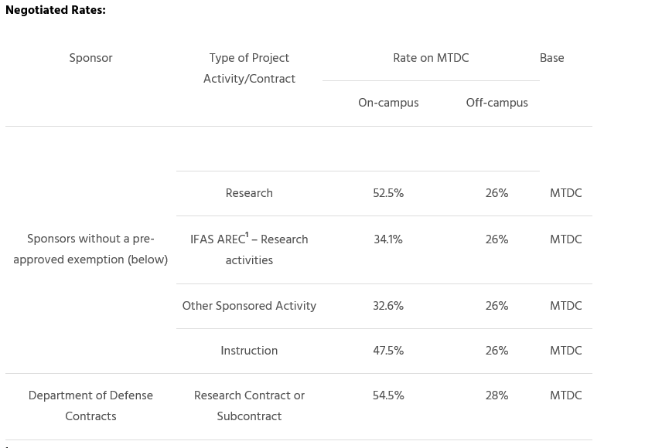

F&A Bases (MTDC& TDC)
Base: The F&A rate is applied to a base of direct costs in order to determine the F&A cost which can be calculated in one of the following ways:
- TDC base = Total Direct Costs. All direct costs are included. There are no exclusions or modifiers. F&A cost = TDC base x F&A rate.
- MTDC base = Modified Total Direct Costs. TDC minus equipment, patient care, tuition, participant support costs, rental costs of off-site facilities, scholarships, fellowships, and the portion of each subaward in excess of $25,000. F&A cost = MTDC base x F&A rate.
- TFFA base = Total Federal Funds Awarded. For USDA or various other sponsor proposals, the F&A is considered to be on the full amount of the award, which is actually calculated using TDC
If the solicitation specifies a rate other than the federally negotiated rate, unless otherwise indicated TDC should be used as the F&A base.
Other Sponsored Activity (OSA): According to 2 CFR 200, Appendix III, Section A.1.c, Other Sponsored Activity means “programs and projects financed by federal and non-federal agencies and organizations which involve the performance of work other than instruction and organized research.” At UF, this includes, but is not limited to IFAS Extension Activities, IFAS SPAs, and some Federal Clinical Trials. Visit Other Sponsored Activities for further clarification and examples.
Other Sponsored Activities includes programs and projects that involve the performance of work other than instruction and organized research. This includes:
- Public service projects, such as sponsored health and/or community service projects, legal clinics and public information services
- Symposia, workshops, seminars and conferences that DO NOT meet guidelines for instruction, research training, or research
- Support for public events
- Extension services
- Field trials for community members and the public that DO NOT meet guidelines for sponsored research.
- Contracts where a unit provides a routine service as part of its normal business operations (designed for auxiliaries only) and not simply for testing services.

